
Dhaka International University
Lab Report details:
Lab Report Topic : Understanding Variable-Length Argument Lists in Java
Lab Report No : 09
Course Title : Object-Oriented Programming Languages
Course Code : 0613-202

Submitted By: | Submitted To:
S M Nabil Ausaf  Roll: 01  Reg No: CS-D-91-23-124492 | Prof. Md. Abdul Based

Date of Submission: ‎27-‎Nov-‎24

Code 1: Understanding Variable-Length Argument Lists in Java

Objective
In this lab is to practice with variable-length argument lists, also known as varargs, in Java by implementing a class named BUnlimitedData. This exercise will help show how one method can be created to handle a variable amount of integer arguments using Java. This makes the handling of parameters easier and more dynamic in Java applications.

Components Used
- Java Development Kit
- IDE such as IntelliJ IDEA or Eclipse
- Computer system with the essential software installed

Theory
Java has something known as Variable-Length Argument Lists. These are method parameters that can take zero to many arguments of a given type. It gives the programmer more flexibility as it has to deal with only variable number of inputs. It is defined as type. parameter where one can pass any number of arguments from zero upwards and they will be handled inside of a receiver's array.
In this example, class BUnlimitedData defines a method named D that uses varargs to accept an arbitrary number of int inputs and prints their sum. Varargs is extremely helpful when we cannot anticipate with certainty just how many arguments might be passed into a particular method.

Problem Solving Procedure
1. Class Definition: Define a class called BUnlimitedData.
2. Create the Varargs Method:
- Define the method D using the syntax int. a so it can receive any number of integer parameters.
- Use the for loop to iterate the integers in array a and sum them up.
- Print out the sum.

3. Write the Main Method: In this main method, create an instance of BUnlimitedData and called the D method with different numbers of arguments.
4. Execute and See the Output: Compile and execute the program to ensure that D correctly calculates and prints the sum for any number of arguments.

Code
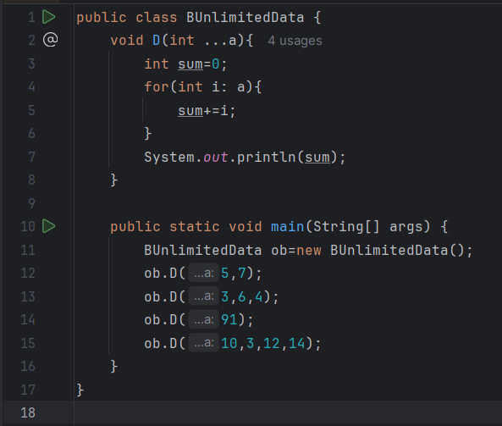

Discussion
Following is the code that can be used to demonstrate the power of Java's varargs, enabling a single method, D, to accept multiple calls with different quantities of parameters without declaring methods or arrays for each case. All supplied int parameters are combined into an array so a for loop to add them up can be rapidly developed. It's so effortless to input various numbers this way and avoids redundancy. The example is a bit contrived, but such code is not all that uncommon.

The Output will show like:
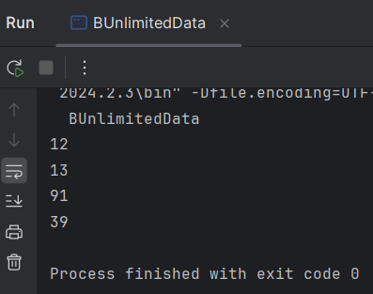

Conclusion
This lab demonstrates how to work in Java with varargs, a way of simplifying the treatment of methods with variable numbers of arguments. With one method and an open-ended parameter list, the solution is compact and reusable. Additionally, this makes Java methods much more adaptable because now they can handle any number of arguments.

